|  |  |  |  |  |  |  |
| --- | --- | --- | --- | --- | --- | --- |
| **Document Name** | **Version** | **Status** | **Date** | **Viewable** | **Reviewer** | **Responsible** |
|  | | | | | | |
| **Promotion provider_Proposal.docx** | Version0.1  - Introduction and Background | Draft | 20-05-2015 | PM, DEV, Advisor | PM, Advisor | Tanawat Sitthitan, Nattakit Chaiwongsri |
| **Promotion provider_Proposal.docx** | Version0.2 - Literature Review  - Quality Standard | Draft | 25-05-2015 | PM, DEV, Advisor | PM, Advisor | Tanawat Sitthitan, Nattakit Chaiwongsri |
| **Promotion provider_Proposal.docx** | Version0.6 - Motivation  - Aims and Objectives  - Deliverable and Limit | Draft | 28-05-2015 | PM, DEV, Advisor | PM, Advisor | Tanawat Sitthitan, Nattakit Chaiwongsri |
| **Promotion provider_Proposal.docx** | Version1.0  - Milestone | Draft | 08-06-2015 | PM, DEV, Advisor | PM, Advisor | Tanawat Sitthitan, Nattakit Chaiwongsri |
| **Promotion provider_Proposal.docx** | Version1.0  - Chart Diagram | Approved | 10-06-2015 | PM, DEV, Advisor | PM, Advisor | Tanawat Sitthitan, Nattakit Chaiwongsri |

Document Designed by

Tanawat Sitthitan  
Nattakit Chaiwongsri  
June 10, 2015   
  
Document Approved by

_________________  
Mr. Phudinan Singkhamfu

June 10, 2015

Table of Contents

Chapter 1 | Introduction and Background 5

Chapter 2 | Literature Review 6

Business Review 6

Business Tools/Software Review 7

Wongnai 7

WhereToEat 9

Trendzap 10

Technology Review 11

1. PHP 11

2. CSS 12

3. HTML 5 13

4. XAMPP 14

5. MySQL 15

6. iOS technology 16

7. Google map 17

8. Bootstrap 3 18

9. Json 19

10. Medoo 20

Development Tools Review 21

1. Xcode 21

2. iOS Simulator 22

3. MySQL Workbench 23

4. PhpStrom 24

Chapter Three | Quality Standard 26

3.1 ISO29110 for Very Small Entity (VSE) 26

3.1.1 Project Management process 26

3.1.2 Software Implementation process 26

Chapter 4 | Project Plan 27

Motivation 27

Aims and Objectives 27

Aims 27

Objective 27

Chart diagram 28

System Architecture 30

Deliverables and Limits 31

Deliverable 31

Limits 35

Schedule & Milestones 36

Chapter 5 | Reference 42

# Chapter 1 | Introduction and Background

The promotion is the quite interested offer from the hotel, restaurant, shopping mall, etc. to the customer. The owner can earn the higher profit. Although, the promotion can make more profit, but sometimes the client does not know which restaurant has promotion and which one does not have, so we decided to develop an application that collect the promotions and provide it to the user.

Over the course of the project, we will establish an iPhone application, database, and server that use PHP to develop. A quick review of the similar application is in the Business Review section. The idea of the system will be to focus on letting user application know any promotions from any restaurants.

Update real-time promotion from the restaurant or hotel is beyond the scope, and they have to update the promotion by themselves. The project will focus exclusively on the providing promotion and notification when the user gets closer than 20 meters. User can also get direction from current location to the restaurant or hotel destination, and they can also turn off the notification when they think it is annoying

# Chapter 2 | Literature Review

## Business Review

Today, searching for the restaurant is very comfortable. The user can use the search engine on the internet with a mobile device or PC. Now a day it has many search engine such as Google, Yahoo, Bing, or Baidu. Most of search engine contain other features that support to find the restaurant such as the map route, image search, video search, or news update.

Most people use the smart device to use the internet such as smartphone, tablet, or laptop, so the most target now a day is the user of these devices, but all feature that need for using the search the restaurant nearby and find route need the location base service and map API.

Location base service is software for the mobile device that can tell the base location of the device. It can service the end user with useful information on the location of the place that we want to find, but this service is requiring the internet connection and GPS (Global Positioning Service) on the device.

So that mean the most smartphone can use the mobile web browser and the application that need internet and GPS. Now a day the social network has the effect of people life, the social network such as Facebook, Twitter, or Instagram.

#### Target

Target of this application is everyone who has the mobile phone with internet connection and GPS. Most specify the tourist that travel and want to find a restaurant this program is the other way to find.

#### Benefit

• Other way to find the restaurant.

• Other way to promote the restaurant through this application

• Save the time to decision the restaurant and save money for promotion

• Provide the discount for user.

## Business Tools/Software Review

### Wongnai



Figure 1: Wongnai

Wongnai is an application that helps you found a restaurant around user from a database of more than 120,000 stores and restaurants in Bangkok and other provinces across the country. Moreover, user can also read reviews and see photos from people, check the latest restaurant that your friends ate. User can search the province has restaurant. If a user opens GPS Location Service, App Wongnai will specify our address immediately.

#### Pros

* Good user interface
* User lives far from restaurant. Users can‘t post or tag in that restaurant.
* Many searching mode:

▪ Friends

▪ Lover

▪ Business

▪ Cheap

▪ Family and kids

▪ Party

▪ Super Hungry

▪ Fast food

#### Cons

* Log out delay sometime do nothing
* Log in with Facebook use a lot of time
* Share to Facebook offend time.

### 

### WhereToEat



Figure 2: WhereToEat

WhereToEat can find restaurants by using GPS. No matter where you are in the world, WhereToEat will display the closest places to eat. User can select from over 45 cuisine types and even get turn-by-turn directions to your chosen restaurant.

An incredibly simple interface hides a sophisticated engine that plugs into the largest restaurant database and global map on the market. Fully customizable, you can order your owns list and make maximum use of your GPS.

#### Pros

* Simple user interface
* Search can be done within a few taps, no typing needed.
* Divided to many categories:

▪ General

* Bakery
* Buffet
* Noodle
* Seafood

#### Cons

* Still not up to date, Many of the shops have close down
* UI slow performance

### Trendzap



*Figure 3: Trendzap*

The new app has garnered the hot menu of restaurant around the country with information and phone number. You can also find restaurants that are around your current location. How to use it is very simple, just press the link on Facebook , it can be used immediately. Do not waste time for hassles. The first page is search page to shows the nearest restaurant. You can also enter a keyword to search for restaurants that have menus you want.

#### Pros

* Find a restaurant with moderate nationality, name and location or price.
* Rate the restaurant was simple, just a click.
* Can post the food. Or add new restaurant
* Can keep track of friends and share food at the Feed.
* To check in and share on the menu as WeChat, Facebook, or your Twitter .

#### Cons

* Add the picture once a time.
* Add only the new picture that take at that time.
* Allow only one review per restaurant.
* Cannot find the restaurant from map.

## Technology Review

### 1. PHP



*Figure 4: PHP*

PHP stands for Hypertext Preprocessor or Personal Home page. It is server-side scripting language. PHP is used to produce dynamic Web pages and display in form of an HTML source document with underlying structure of language is C, Java, and Perl. PHP can be usable most in Web servers and also as standalone shell on almost every operating system and platform free of charge.

#### Alternative Technology

* + ASP .NET

#### The selection of this technology

We chose PHP because it easy learns and it can work efficiency. PHP also is free software released under the PHP license and anyone can access it. So, it is extremely popular in this present. Moreover, PHP has community supported and the great guide to developing.

### 2. CSS

Figure 5: CSS (Cascading Style Sheets)

Cascading Style Sheets (CSS) is a style sheet language used for describing the presentation semantics (the look and formatting) of a document written in a markup language. Its most common application is to style web pages written in HTML and XHTML, but the language can also be applied to any kind of XML document, including plainXML, SVG and XUL.

CSS is designed primarily to enable the separation of document content (written in HTML or a similar markup language) from document presentation, including elements such as the layout, colors, and fonts. This separation can improve content accessibility, provide more flexibility and control in the specification of presentation characteristics, enable multiple pages to share formatting, and reduce complexity and repetition in the structural content (such as by allowing for tableless web design). CSS can also allow the same markup page to be presented in different styles for different rendering methods, such as on-screen, in print, by voice (when read out by a speech-based browser or screen reader) and on Braille-based, tactile devices. It can also be used to allow the web page to display differently depending on the screen size or device on which it is being viewed. While the author of a document typically links that document to a CSS style sheet, readers can use a different style sheet, perhaps one on their own computer, to override the one the author has specified.

CSS specifies a priority scheme to determine which style rules apply if more than one rule matches against a particular element. In this so-called cascade, priorities or weights are calculated and assigned to rules, so that the results are predictable.

#### Alternative Technology

-

#### The selection of this technology

CSS is used to allow the HTML formatting to be done outside of the HTML code and allow for consistent themes to be applied throughout the website.

### 3. HTML 5



Figure 6: HTML5

HTML5 is a markup language for structuring and presenting content for the world wide web and a core technology of the Internet. It is the fifth revision of the HTML standard (created in 1990 and standardized as HTML4 as of 1997) and, as of December 2012, is a W3C Candidate Recommendation. Its core aims have been to improve the language with support for the latest multimedia while keeping it easily readable by humans and consistently understood by computers and devices. HTML5 is intended to subsume not only HTML4 but XHTML 1 and DOM Level 2 HTML as well.

#### Alternative Technology

* + Javascript

#### The selection of this technology

With HTML5 stands another tech which is very important to professional development – CSS3. Often, when using HTML5 it is assumed that CSS3 is included. This is also the case with our project. HTML5 meshes perfectly with the new CSS specification. CSS allows us to organize our visual styles in one quick worksheet, while keeping the content and structure of our website separate. This will help keep the work organized and allow for easy styling changes. The content of the website is easily changed, while keeping the formatting and overall structure the same.

### 4. XAMPP



Figure 7: XAMPP

XAMPP is a simulation of the machine to be a Web Server by itself. It use for development and testing software. So, the security system is set to be lower than the actual system. It is free and open-source program that combining of developing system as a package for easy installation. In package, it included Apache that is a Web Server, MySQL that is a free database, PHP language for developing Web applications, FlieZilla that is used to connect to a FTP, and TomCat that is Web server of XAMPP. Moreover, it has an auto to configuration.

#### Alternative Technology

* + MAMP
  + AMPPS
  + Abyss Webserver

#### The selection of this technology

XAMPP is a free and open-source program. It is a package that contains several programs about developing software. It easy to uses and install. So, it helps to preparation to use is easier and faster.

### 5. MySQL



**Figure 8: MySQL**

MySQL is a open source Relational Database Management System. MySQL is very fast reliable and flexible Database Management  System. It provides a very high performance and it is multi threaded and multi user Relational Database management system.

MySQL is one of the most popular relational database Management System on the web. The MySQL Database has become the world's most popular open source  Database, because it is free and available on almost all the platforms. The MySQL can run on Unix , window, and Mac OS. MySQL is used for the internet applications as it provides good speed and is very secure. MySQL was developed to manage large volumes of data at very high speed to overcome the problems of existing solutions. MySQL can be used  for verity of applications but it is mostly used for the web applications on the internet.

#### Alternative Technology

* + Oracle
  + DB2

#### The selection of this technology

Many of the world's largest and fastest-growing organizations including Facebook, Google, Adobe, Alcatel Lucent and Zappos rely on MySQL to save time and money powering their high-volume Web sites, business-critical systems and packaged software.

Below you will find valuable resources including case studies and white papers that will help you implement cost-effective database solutions using MySQL.

### 6. iOS technology



Figure 9: iOS technology

iOS is Apple's mobile operating system used to run the popular iPhone, iPad and iPod Touch devices. Formerly known as the iPhone OS, there are over 300,000 iOS applications available for download in the Apple app store, the most popular app store of any mobile device. iOS utilizes a multi-touch interface where simple gestures are used to operate the device, like swiping your finger across the screen to move to the next page or pinching your fingers to zoom out.

#### Alternative Technology

* Android
* Window phone by Microsoft Corporation
* Black Berry by Research In Motion Limited (RIM)

#### The selection of this tool

The iPhone is a new mobile device for the developer. It is interesting to develop. iOS user interface is design in multi-touch feature is useful and friendly interface more than other touch screen mobile phone. Additional, nowadays there are many increasing of Smart Phone especially IPhones. Finally, there are many tutorials for iOS to learn from Internet

### 7. Google map



Figure 10: Google Maps

Google Maps is a Web-based service that provides detailed information about geographical regions and sites around the world. In addition to conventional road maps, Google Maps offers aerial and satellite views of many places. In some cities, Google Maps offers street views comprising photographs taken from vehicles.

#### Alternative Technology

Bing map

#### The selection of this tool

The Google Maps application program interface makes it possible for Web site administrators to embed Google Maps into a proprietary site such as a real estate guide or community service page.

### 8. Bootstrap 3



Figure 11: Bootsrap

Bootstrap is an open-source Javascript framework developed by the team at Twitter. It is a combination of HTML, CSS, and Javascript code designed to help build user interface components. Bootstrap was also programmed to support both HTML5 and CSS3.

#### Alternative Technology

Foundation

#### The selection of this tool

1. Responsive utility classes, greater control over visibility and hidden classes for block, inline-block, and inline

2. Responsive embeds classes to proportionately scale down iframes or embeds

### 9. Json



Figure 12: Json

JavaScript Object Notation is a lightweight data-interchange format. It is easy for humans to read and write. It is easy for machines to parse and generate. It is based on a subset of the JavaScript Programming Language, Standard ECMA-262 3rd Edition - December 1999

#### Alternative Technology

XML

#### The selection of this tool

With the rise of AJAX powered sites, it’s becoming more and more important for sites to be able to load data quickly and asynchronously

### 10. Medoo



Figure 13: Medoo

Medoo is the lightest PHP database framework to accelerate development, easy-to-use, easy-to-learn, and optimized for high performance to increase the development experience and user experience for web application. It`s suitable for every PHP development project with SQL database needed.

#### Alternative Technology

-

#### The selection of this tool

1. Compatible, Support various SQL database, including MySQL, MSSQL, SQLite, MariaDB, Oracle, Sybase, PostgreSQL and more.

2. Security, Prevent SQL injection.

3. Powerful , Support various common and complex SQL queries.

## Development Tools Review

### Xcode



Figure 14: **Xcode**

Xcode is an Integrated Development Environment (IDE) containing a suite of software development tools developed by Apple for developing software for OS X and iOS. First released in 2003, the latest stable release is version 4.6 and is available via the Mac App Store free of charge for Mac OS X Lion and OS X Mountain Lion users. Registered developers can download preview releases and previous versions of the suite through the Apple Developer website.

#### Alternative Tool

- No alternative

#### The selection of this tool

Xcode is the Cocoa application implementation tool. It used from beginners to experienced developer. The easiest way to implementation iOS application is to use this tool.

### iOS Simulator

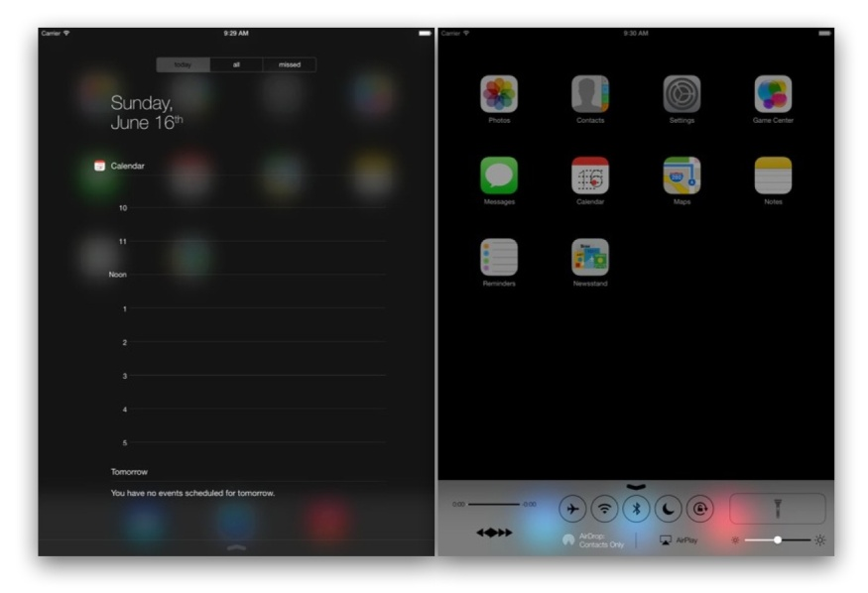

Figure 15: iOS Simulator

IOS Simulator is a valuable tool, never make it the only way you test an app, because iOS Simulator is an app running on a Mac, it has access to the computer‘s memory, which is much greater than the memory found on a device. As a result of the increased memory, iOS Simulator is not an accurate test of an app‘s memory usage. For this same reason, you should always test the performance of your app‘s user interface on a device.

#### Alternative Tool

- No alternative software tool for simulating iOS devices.

#### The selection of this tool

The iOS simulator is simple and suitable for simulating application without using the actual device. It is fast and easy

### 3. MySQL Workbench



Figure 16: MySQL Workbench

MySQL Workbench is a unified visual tool for database architects, developers, and DBAs. MySQL Workbench provides data modeling, SQL development, and comprehensive administration tools for server configuration, user administration, backup, and much more. MySQL Workbench is available on Windows, Linux and Mac OS X.

#### Alternative Technology

-

#### The selection of this tool

It enables a DBA, developer, or data architect to visually design, model, generate, and manage databases. It includes everything a data modeler needs for creating complex ER models

### PhpStrom



Figure 17: Php Strom

PhpStorm is the most intelligent php IDE. It is smart code editor provides excellent support for PHP (including the latest language versions and frameworks), HTML, JavaScript, CSS, Sass, Less, CoffeeScript, and many other languages. Enjoy coding with intelligent context-aware code completion, error detection, and on-the-fly code inspections & fixes.

#### Alternative Technology

* TextWranger
* Sublime text
* Dreamweaver
* AptanaStudio

#### The selection of this technology

**1. Smart PHP Code Editor**

The editor that actually 'gets' your code and deeply understands its structure, supporting all PHP language features for modern and legacy projects. Provides the best code completion, refactoring, on-the-fly error prevention, and more.

**2. Code Quality Analysis**

Hundreds of inspections take care of verifying your code as you type, analyzing the whole project. PHPDoc support, code (re)arranger and formatter, quick-fixes, and other features help you write neat code that’s easy to support.

**3. HTML/CSS/JavaScript Editor**

All the cutting edge front-end technologies are included, such as HTML5, CSS, Sass, Less, Stylus, CoffeeScript, TypeScript, Emmet, and JavaScript, with refactoring, debugging and unit testing. Live Edit let you see changes instantly in the browser.

**4. Debugging and Testing**

Zero-configuration debugging makes it really easy to debug and profile your PHP applications with either Xdebug or Zend Debugger. PHPUnit and Behat support lets you develop and run tests right from the IDE.

# Chapter Three | Quality Standard

## 3.1 ISO29110 for Very Small Entity (VSE)

ISO29110 is a guide applies to a Very Small Entity (VSE), enterprise, organisation, department or project up to 25 people, dedicated to software development. The Guide provides Project Management and Software Implementation processes which integrate practices based on the selection of ISO/IEC 12207- *Systems and Software Engineering —Software Life Cycle Processes* and ISO/IEC 15289 *Software Engineering – Software Life Cycle Process – guidelines for the content of software life cycle process information products (documentation)* standards elements.

### Project Management process

The purpose of the Project Management process is to establish and carry out in a systematic way the tasks of the software implementation project, which allows complying with the project’s objectives in the expected quality, time and cost.

Selected process

1. Project Planning Process
2. Project Plan Execution Process
3. Project Assessment and Control Process
4. Project Closer Process

### Software Implementation process

The purpose of the Software Implementation process is the systematic performance of the analysis, design, construction, integration and tests activities for new or modified software products according to the specified requirements.

Selected process

1. Software Implementation Initiation Process
2. Software Requirements Analysis Process
3. Software Architectural Design Process
4. Software Construction Process
5. Software Integration and Test Process
6. Software Delivery Process

# Chapter 4 | Project Plan

## Motivation

The motivation for our project is twofold. Our primary goal is to establish an application for further development into a system focusing on letting user know the special offer. The secondary goal is that with the establishment of this application, system can provide a much needed restaurant, and help user to get direction to the restaurant. Within this second motivation is also the simply way to find which restaurant created promotion.

## Aims and Objectives

### Aims

This application will develop follow by ISO29110 and allow a user conveniently find a special offer or promotion from the restaurant or hotel, as well as get notification while user get close to the restaurant. This application also provides the route and distance of the restaurant. This application will advise a famous restaurant to user without any typing. It can receive information from the owners who want to promote their business. It can receive feedback and review from user. User allows to share and check in to show their friend. We will develop this application to be guidance for the tourist.

### Objective

* + To provide a software in mobile platform and database to a Promotion Provider System.
  + To provide a system’s notification to notify user.
  + To allow the system easily for adding and removing restaurant or hotel from system.
  + Apply knowledge to develop real software application.
  + Provide a promotion and discount to user.
  + Provide the recommended a restaurant to tourists.

### Chart diagram

#### Mobile application (ios)

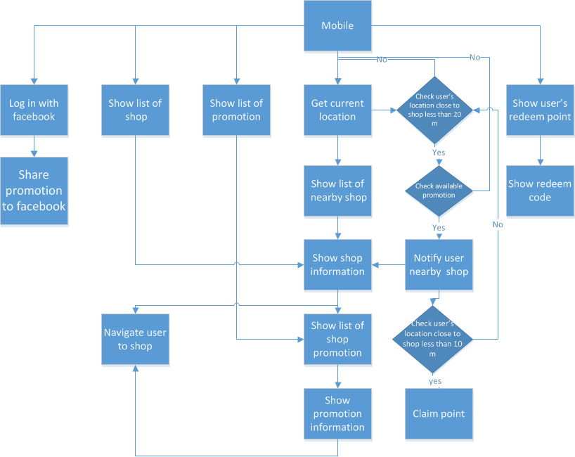

#### Web application

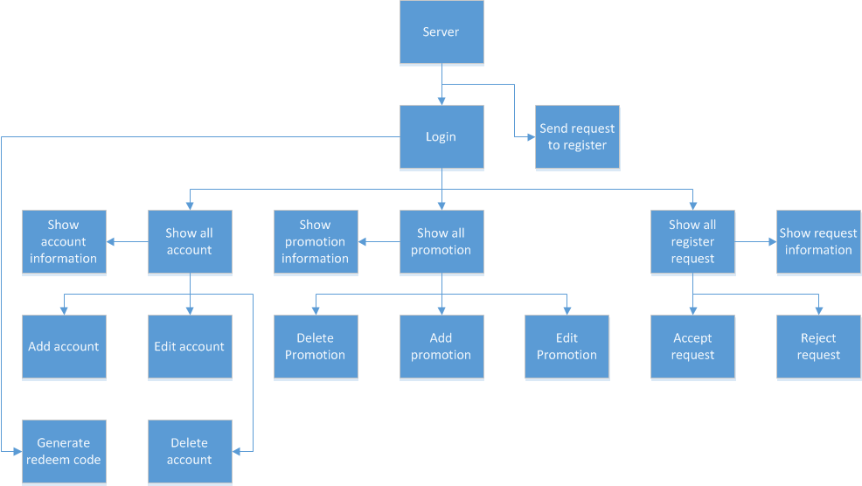

### System Architecture

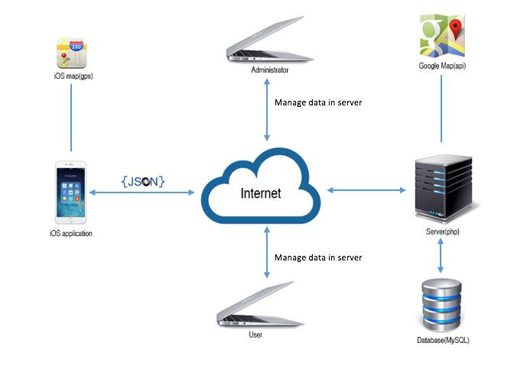

Figure 18: System Architecture

This project will have 2 sides, the first is client side that is the iPhone application. The client will use apple API to provide a map. The second is server side that is web and database. In this system client need to connect a server, then server will connect to the database and sent the data back to the client via the internet in the form of JSON. The client application cannot retrieve information without connect to server because every data and information of the restaurant of the hotel will store in the database server. User(Hotel or restaurant) can add promotions into our system, and admin can also manage data in the system which are adding, editing and deleting.

## Deliverables and Limits

### Deliverable

**Web Server**

**Add data and insert information**

Accounts and promotions that easily to add with minimal effort.

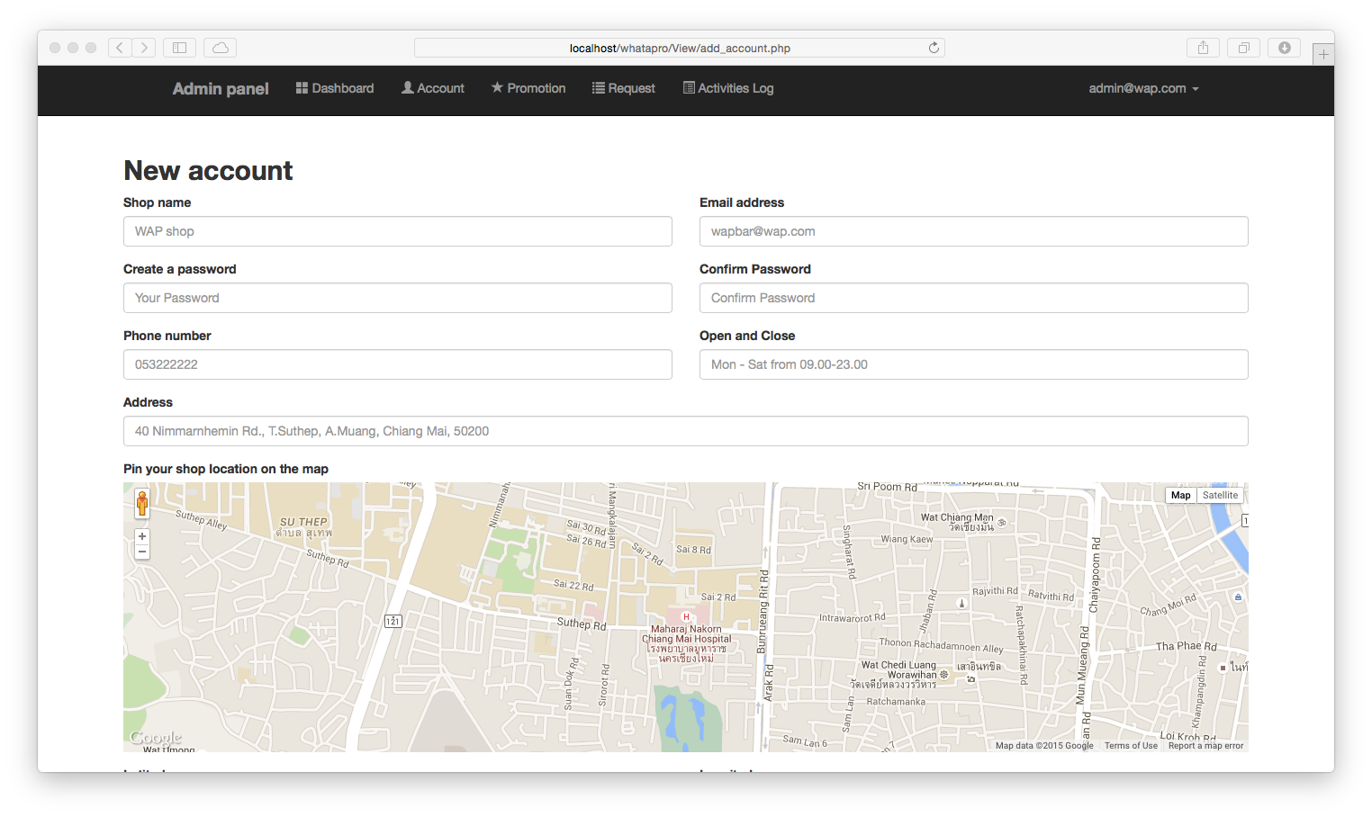

* Add new accounts and information including shop image
* Add new promotion to provide information to mobile application

**Edit and update**

Edit and update the information by changing the existing information or remove it and insert new information.

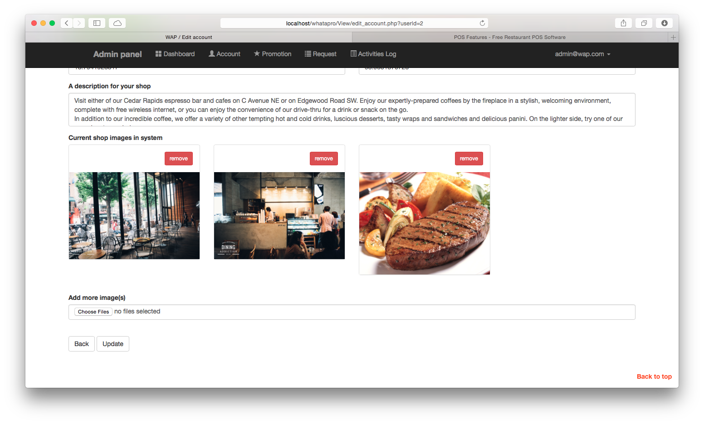

* Change password
* Update shop information
* Update promotion information

**Delete**

Lets user delete unwanted promotions and accounts.

* Delete account and shop information included its image(s)
* Delete promotion included its image(s)

**Search and find**

The best way to find the shop or promotion which is in your mind

* Search shop by name
* Search shop by id
* Search shop by email
* Search shop by category
* Search promotion by name
* Search promotion by shop name
* Search promotion by category

**The usability with real-time updating screen**

Prevent losing data via updating the shop information or promotion information.

**Generate**

Very easy to provide unique redeem code and also with barcode to mobile application.

**Track**

Tracks every actions of user in system by record logs, letting admin to track promotion. The software is designed to let admin view which promotion are belonging to each shop.

**Secure and permission**

Without having email and password, system will not allowed to login. “Permission denied” will show if user role try to access administrator page. It also show if user does not login and try to redirect page by URL.

**Show or display**

Easy to view account, promotion, logs and register request

* List of account
* List of promotion
* List of request
* List of logs
* Show single account information
* Show single promotion information included image(s)
* Show single register request information included image(s)

**Mobile application**

**Notification**

Notifying user the promotion when user is in range. Turn off notification when user unwanted receive it.

**Navigate**

Navigate user from current location to shop.

**Show and display**

* Show the all promotions and all shops
* Show nearby shops and promotions
* User’s redeem code
* Promotion information
* Shop information

**Claim point**

Let user collecting the point when they are close to the shop and apply point later

**Connecting to Facebook**

Let user login by using Facebook account. User also can share interesting shop or promotion to Facebook.

**Documentation**

* + Proposal
  + Project plan
  + Software requirement specification
  + Software design documentation
  + Unit test record
  + Traceability record
  + Test plan and Test record
  + Integration test record
  + System test record

### Limits

* This application support only iOS8 or later on device IPhone5 and iPhones 6, iPod touch.
* Our focus of development and testing is limited exclusively to the technologies established, and we share the limits involved with developing on HTML5, CSS3, PHP, Objective-C and MySQL.
* This application not available without Internet connection.
* GPS may not accurate on the rainy day.

## Schedule & Milestones

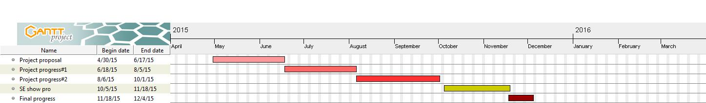

Figure 19: Schedule and Milestone

* Project Proposal Presentation
* Progress Report I
* Progress Report II
* Final Project Presentation.

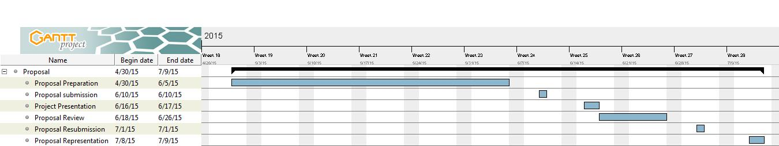

**Figure 20: Proposal** **Milestone**

* + - * Proposal Preparation
      * Proposal Submission
      * Proposal Presentation
      * Proposal Reviewing
      * Proposal Resubmission
      * Proposal Representation

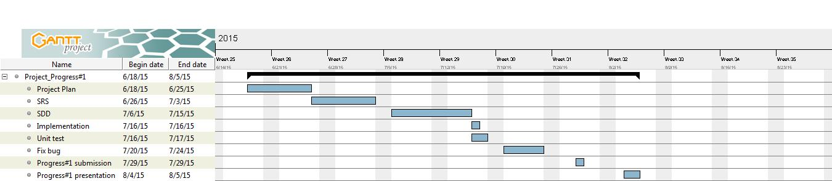  
  
**Figure 21: Progress I** **Milestone**

* + - * Feature# 1 Managing shop owner: System provide managing function(add, update, delete)
      * Feature# 2 Managing promotion: System provide managing function(add and delete)
      * Feature# 3 Changing password: All user type can change their password
      * Project Plan
      * Software Requirement Specification(SRS)
      * User Interface Design
      * Feature Implementation
      * Unit Test
      * Fix bugs
      * Progress Report I Submission
      * Progress Report I Presentation

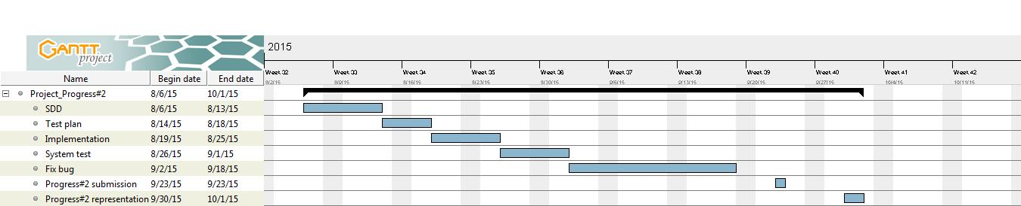

**Figure 22: Progress II** **Milestone**

* + - * Feature# 4 Show promotion information: System provide the promotion information
      * Feature# 5 Notification: System will notify user application when they get closer than 20 meters
      * Feature# 6 Turn off notification: User application can turn off notification
      * Software Design Document for Progress II
      * Software Test Plan for Progress II
      * Feature Implementation
      * System Test
      * Fix Bugs
      * Progress Report II Submission
      * Progress Roport II Presentation

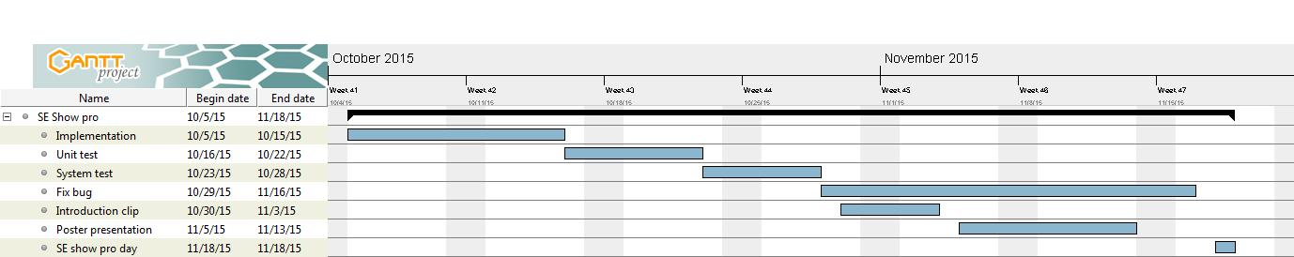

**Figure 23: SE Show Pro** **Milestone**

* + - * Feature# 7 Searching: User application can search by place’s name
      * Feature# 8 Near by: User application can see the promotion place in setting range
      * Feature# 9 Single sign on: User application can sign in to system by using Facebook’s account
      * Feature# 10 Sharing promotion: User application can share any promotions to Facebook
      * Unit test
      * System test
      * Fix bugs
      * 30 seconds Introduction Clips
      * Poster A1 For Presentation
      * SE Show Pro

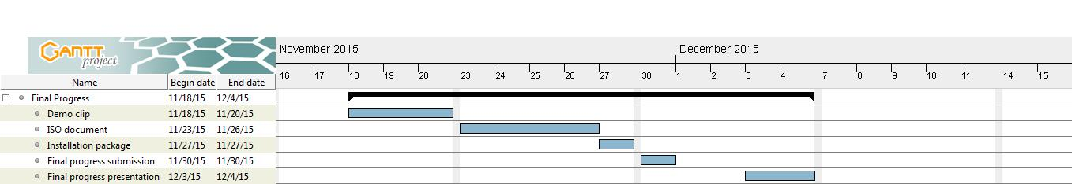

**Figure 24: Final Progress** **Milestone**

* + - * 5 minutes Demo Program Clip
      * The Full ISO 29110 Document
      * Installation Package
      * Final Report Submission
      * Final Report Presentation

# Chapter 5 | Reference

#### [1] My SQL

Author : Rose India  
 Resource : http://www.roseindia.net/mysql/mysql5/what-is-mysql.shtml

#### [2] Adobe Dreamweaver

Author : Adobe staff  
 Resource : <http://www.adobe.com/in/products/dreamweaver.html>  
 [http://www.webdesigndev.com/dreamweaver/10-good-and-10-bad-things-about- adobes-dreamweaver](http://www.webdesigndev.com/dreamweaver/10-good-and-10-bad-things-about-%20%20adobes-dreamweaver)

#### [3] Wongnai

Author : Google Play staff  
 Resource : <https://play.google.com/store/apps/details?id=com.wongnai.android>

#### [4] WhereToEat

Author : Thaiware  
Resource : <http://software.thaiware.com/11205-Where-to-Eat-App.html>

#### [5] iOS Simulator

Author : Apple  
 Resource :

[https://developer.apple.com/library/ios/documentation/IDEs/Conceptual/iOS_Simulator_Guide/Introd uction/Introduction.html](https://developer.apple.com/library/ios/documentation/IDEs/Conceptual/iOS_Simulator_Guide/Introd%20uction/Introduction.html)

#### [6] Xcode

Author : Apple  
 Resource : <https://developer.apple.com/xcode/>

#### [7] Xampp

Author : Apachefriends  
 Resource : http://www.apachefriends.org/index.html